Ideation Phase
Empathize & Discover

Date | 31 January 2025
Team ID | LTVIP2026TMIDS66408
Project Name | Asset Management Portal
Maximum Marks | 4 Marks

Empathy Map Canvas Management Asset Portal::
An empathy map canvas is a simple visual tool used to understand the behaviors, needs, and experiences of users working with a Management Asset Portal. It helps teams analyze how administrators or employees manage assets, track records, and handle asset-related tasks.
By considering what users think, feel, say, and do, teams can identify challenges such as difficulty in tracking assets, maintaining accurate data, or generating reports. This understanding helps in designing a more user-friendly, efficient, and reliable asset management system that meets user needs and improves overall productivity.
Example:
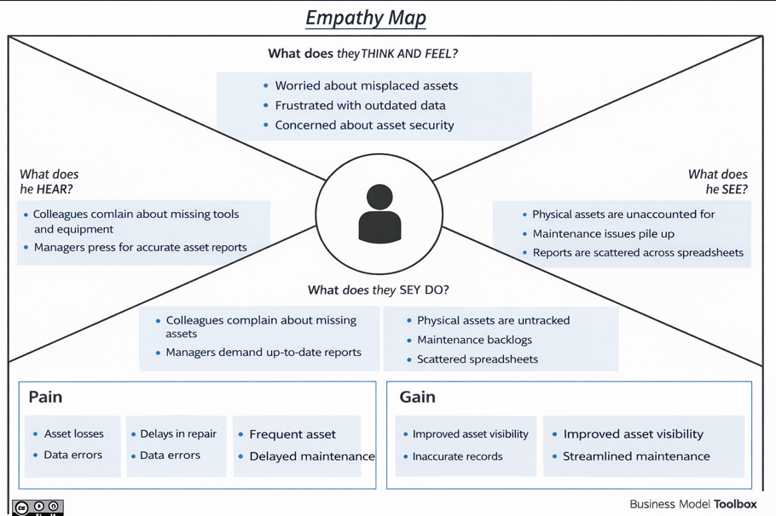

Reference: https://www.mural.co/templates/empathy-map-canvas

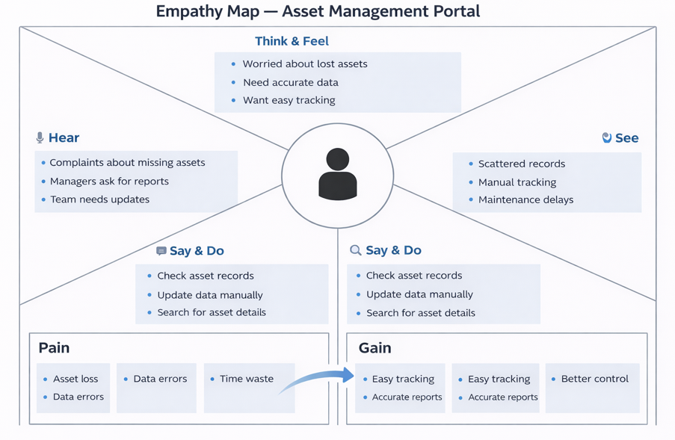
Example: Asset Management Portal Application

